1. **Download MongoDB**
2. **Set up MongoDB after creating data\db folder manually in C drive**
3. **Start Mongodb from command prompt, after either manually executing mongod and mongo commands or directly by executing mongo (if MongoDb as service was selected during installation)**

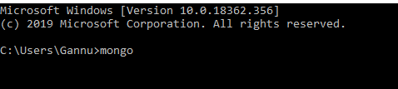

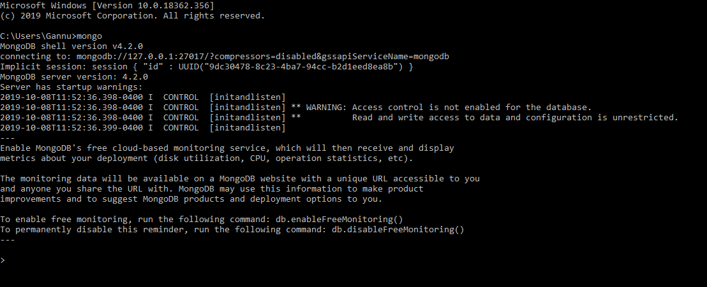

1. **List all the database (I have already created “yashFSE” database prior to this assignment)**

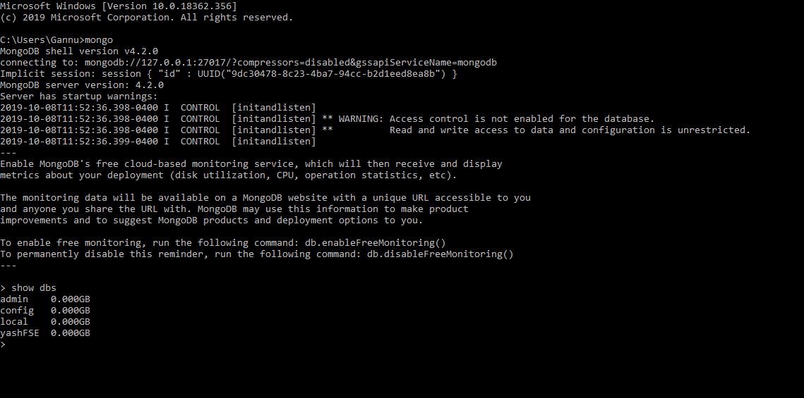

1. **Create database -**

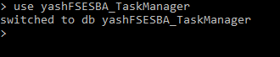

1. **Insert Keyvalue#1 in Collection -**



1. **Insert Keyvalue#2 in Collection -**



1. **Insert Keyvalue#3 in Collection -**



1. **List all databases -**

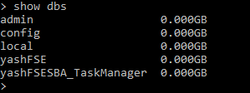

1. **List all collections -**



1. **List all values inside the collection -**

